EMBEDDED SYSTEMS PROJECT REPORT
Smart Electronic Safe
Multi-Factor Authentication, RFID Access & Real-Time Feedback
ESP32 · RC522 RFID · 4×4 Keypad · SH1106 OLED · Solenoid Lock

Table of Contents
Table of Contents 1
1. Project Title 4
2. Project Description 4
2.1 Overview 4
2.2 Real-World Relevance 4
2.3 Problem Statement 4
2.4 Objectives 5
3. Features 5
3.1 Numeric PIN System 5
3.2 RFID Authentication 5
3.3 OLED Feedback System 6
3.4 Solenoid Lock 6
3.5 LED Indicators 6
3.6 Buzzer Alerts 6
3.7 Master Reset & Administrative Menu 6
3.8 System Disarm Switch 7
4. System Architecture & Design 7
4.1 Component Interaction 7
4.2 Data Flow 7
4.3 Control Logic Finite-State Machine 7
5. List of Components 9
6. Physical Build Circuit & Maquette 15
6.1 Internal Circuit 15
6.2 Maquette Closed Configuration 15
6.3 Maquette Open Configuration 16
7. Implementation Steps 16
7.1 Mechanical Construction 16
7.2 Electrical Wiring 16
7.3 Pin Map 17
7.4 Firmware Workflow 17
7.5 Testing & Debugging 17
8. System Operation 18
9. Engineering Challenges & Solutions 18
9.1 RC522 Locking After Relay Switching 18
9.2 Toggle-Switch Contact Bounce 19
9.3 Battery-Powered Voltage Headroom 19
9.4 OLED Contrast Inside the Enclosure 19
9.5 Pin Conflicts with Strapping Pins 19
10. Future Improvements 19
10.1 Mobile-App Integration 19
10.2 Cloud / IoT Telemetry 19
10.3 Persistent Credential Storage 19
10.4 Biometric Authentication 20
10.5 Tamper Detection & Camera 20
10.6 Supercapacitor Backup 20
11. Conclusion 20
12. Appendix ESP32 Firmware Source Code 21

1. Project Title
Smart Electronic Safe A Multi-Factor Authentication System Using ESP32, RFID and OLED Feedback
This report documents the design, construction and evaluation of a microcontroller-driven security safe developed as an embedded systems prototype project. The system fuses two independent authentication modalities: a numeric PIN entered through a 4×4 membrane keypad and a contact-less RFID credential, with finite-state firmware running on an ESP32 microcontroller. Real-time feedback is rendered on a 128×64 OLED display, while a solenoid-driven door, multi-colour LEDs and a piezo buzzer complete the user-facing actuation layer. The result is a low-cost, fully self-contained battery-powered safe whose behaviour, security policies and visual feedback rival commercial-grade products.

2. Project Description

2.1 Overview
The Smart Electronic Safe is an embedded-systems device that secures valuables behind an electromechanical door, releasable only after a verified credential is presented. Two independent authentication paths are supported. First, a four-digit numeric PIN can be entered through a tactile 4×4 membrane keypad. Second, a contact-less RFID tag may be scanned against the front-mounted RC522 reader. A 128×64 OLED screen provides continuous, animated feedback to the user, ranging from idle waiting states to access-granted celebrations and lock-out countdowns. A solenoid lock, driven through an opto-isolated relay module, performs the physical actuation, while a piezo buzzer and red/green LEDs provide audible and visual confirmation.

2.2 Real-World Relevance
Modern households, hotels and small offices increasingly demand smart locking solutions that combine reliability with rich human-machine feedback. Mechanical key-based safes are inherently limited; lost or duplicated keys compromise the entire system, and they offer no user-level audit trail. Conversely, fully cloud-connected smart safes raise privacy concerns and can be rendered unusable by network outages. The presented design occupies a deliberate middle ground: it offers contemporary convenience features RFID, animated feedback, master-card administration and brute-force protection while remaining entirely offline, low-power and battery-operable.

2.3 Problem Statement
Conventional electronic safes typically suffer from at least one of the following weaknesses: a single point of authentication that, if compromised, grants full access; minimal user feedback that leaves the operator uncertain whether the system is alive, busy or locked out; limited extensibility for adding or revoking credentials in the field; and dependence on continuous mains power. The objective of this project is to design and build a self-contained smart safe that simultaneously addresses all four shortcomings within practical budget and time constraints.

2.4 Objectives
- Implement a robust, deterministic finite-state firmware that handles concurrent inputs from a keypad, an RFID reader, a system switch and a manual lock button without race conditions.
- Provide two independent authentication paths PIN and RFID that can be configured, enrolled and revoked at run-time through a hidden administrative menu.
- Deliver continuously animated, professional-grade visual feedback on a 128×64 OLED display, including idle, scanning, granted, denied, lock-out, admin and disarmed screens.
- Enforce brute-force protection through a configurable failed-attempt counter and a 30-second lock-out routine that visually conveys the remaining cooldown to the user.
- Operate from a 4-cell lithium-ion battery pack regulated to the appropriate logic and actuator voltages, allowing the safe to remain functional during power outages.
- Document the build process and source code in sufficient depth for the work to be reproduced, audited and extended by future developers.

3. Features
The safe exposes a layered set of features that have each been implemented in firmware as discrete modules. The most prominent are summarised below; a deeper engineering narrative for every feature follows in the dedicated subsections.

3.1 Numeric PIN System
The numeric PIN system constitutes the primary fall-back authentication path. The user invokes it by pressing the # key from the idle screen, which transitions the firmware to the ENTER_PIN state. Each subsequent key press is validated against the legal character set, appended to a fixed-size buffer of up to eight digits, and visually represented by a filled disc on the OLED a privacy-preserving counterpart to printing the digits in clear. The asterisk key serves as a backspace, while a final hash terminates entry and triggers a constant-time comparison against the firmware-stored reference PIN. A 15-second inactivity timeout silently returns the system to the idle state to mitigate shoulder-surfing scenarios in which an entry has been started but abandoned.

3.2 RFID Authentication
The contact-less authentication channel is built around an MFRC522 reader operating at 13.56 MHz over the SPI bus. Whenever the firmware is in the IDLE or SCAN_RFID state, the antenna is polled for the presence of an ISO/IEC 14443A card. The four-byte UID of any detected tag is matched against an in-memory whitelist of authorised cards. A dedicated master card grants entry into the administrative menu, where new cards may be enrolled or revoked at run-time. To improve robustness in the noisy environment of an actuating relay, the firmware periodically toggles the RC522 antenna and performs a hard reset of the reader after every door event, eliminating the freeze-states observed during early integration testing.

3.3 OLED Feedback System
All user feedback is rendered on a 128×64 OLED display driven by the U8g2 library. The firmware contains a custom animation framework including helpers for centred text, screen flashing, growing concentric circles and animated lock icons used by every visible state. Idle screens cycle through subtle indicator animations that confirm the device is alive without distracting the user; scan screens project expanding RF wavefronts to communicate that the antenna is active; granted/denied transitions employ contrasting positive and negative micro-animations; the lock-out state is presented as a countdown bar synchronised with red-LED blinking; and the disarm state shows a sleeping icon. The result is feedback that is both diagnostically informative and aesthetically polished.

3.4 Solenoid Lock
The mechanical actuation layer consists of a 12-volt latching solenoid driven through a single-channel relay. When the firmware enters the ACCESS_GRANTED state, the relay coil is energised, pulling the solenoid plunger and freeing the bolt. The solenoid is intentionally specified to be of the spring-return type, so that any sudden loss of power immediately re-engages the lock a fail-secure failure mode. The relay isolates the high-current actuator path from the ESP32 GPIO, protecting the microcontroller from the back-EMF generated when the coil is de-energised.

3.5 LED Indicators
Two indicator LEDs supplement the OLED for at-a-glance feedback. A green LED illuminates whenever access has been granted and the door is unlocked, and is automatically extinguished when the firmware re-locks. A red LED is used for negative feedback failed PIN attempts, unauthorised cards and the periodic blink of the lock-out countdown. Both LEDs are driven through current-limiting resistors sized for a continuous forward current well below the manufacturer’s maximum, ensuring an indefinite operational life-time.

3.6 Buzzer Alerts
A piezo buzzer provides distinct audible feedback for keypress events, success melodies, failure sounds and locking confirmations. The firmware exposes a single playMelody() helper that consumes parallel arrays of frequencies and durations, allowing future melodies to be added with minimal effort. Audible feedback is psychologically important in a safe context: it confirms that the device has registered each interaction even when the user’s gaze is on the keypad rather than the OLED.

3.7 Master Reset & Administrative Menu
The firmware exposes an out-of-band administrative menu that can be reached only by presenting the dedicated master card (or by pressing the asterisk key in the IDLE state). From within the menu, the operator may add a new card (the next scanned UID is appended to the whitelist), remove a card (the next scanned UID is searched and deleted), or simply exit. All changes are immediate and visually confirmed through dedicated card-action animations on the OLED. The master UID is held in firmware and cannot be deleted, ensuring that the operator can always recover administrative control.

3.8 System Disarm Switch
A panel-mounted toggle switch allows the entire authentication subsystem to be disarmed for situations such as maintenance, debugging or extended periods in which the safe must remain unlocked (for example, the demonstration session). When the switch is in the OFF position, the firmware enters the DISARMED state and renders a sleeping-zZz icon on the OLED. The switch is read with a 40-millisecond software debounce that eliminates contact bounce without introducing a perceptible response delay.

4. System Architecture & Design

4.1 Component Interaction
Conceptually, the system is organised around the ESP32 microcontroller as the central control element. Three classes of peripheral revolve around it. Input devices the 4×4 keypad, the RC522 RFID reader, the disarm switch and the lock button feed user intent into the firmware. Output devices the OLED display, the relay-driven solenoid, the buzzer and the LEDs render the firmware’s response back to the physical world. The power subsystem sits orthogonal to both, supplying the regulated voltages required by each module from a 4-cell lithium-ion battery pack.

4.2 Data Flow
The keypad uses a row-column matrix scan implemented by the Keypad library, producing a single-character event each time a key is pressed. The RC522 communicates over SPI at clock rates up to 10 Mbit/s, returning a four-byte UID for every successful card read. The OLED is driven over the I²C bus at 400 kHz, with the U8g2 library performing all graphics rendering in a 1 KB internal frame buffer that is then flushed to the panel. The relay is energised through a single GPIO pin set LOW (active-low module). The buzzer is driven through the ESP32’s built-in tone() facility, producing precisely-timed sinusoidal pulses without consuming additional CPU cycles. All of these data paths are coordinated by the cooperative state machine described in the next subsection.

4.3 Control Logic Finite-State Machine
The firmware implements a deterministic finite-state machine with ten states: IDLE, SCAN_RFID, ENTER_PIN, ACCESS_GRANTED, ACCESS_DENIED, LOCKED, SYSTEM_DISARMED, ADMIN_MENU, ADD_CARD and REMOVE_CARD. Every iteration of the main loop dispatches to a state-specific handler that polls the relevant inputs, updates the OLED animation, and may transition to a new state via the changeState() helper. State transitions record both the previous and the new state so that one-shot side effects (such as energising the relay on entry to ACCESS_GRANTED, or hard-resetting the RC522 on entry to LOCKED) are guaranteed to fire exactly once per transition, regardless of how many loop iterations the system spends in a given state.

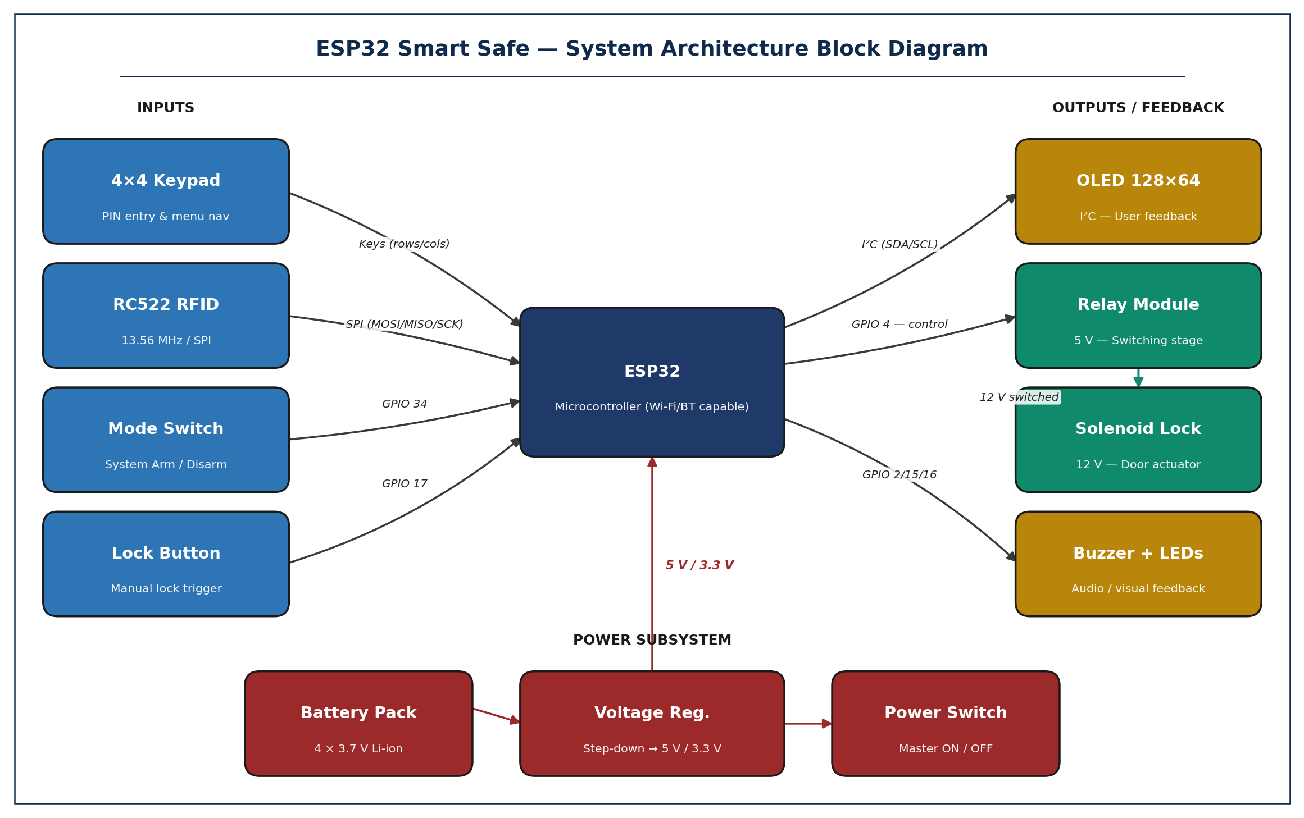
Figure 1. High-level architecture showing the ESP32 as the central controller surrounded by input devices, output actuators and the regulated power subsystem.

5. Simulation
Prior to fabricating any hardware, the entire system was modelled and exercised in a virtual breadboarding environment (Wokwi). The simulation captured every electrical connection between the ESP32 and its peripherals the SPI bus to the RC522, the I²C bus to the OLED, the GPIO drives to the LEDs, the relay and the buzzer, and the regulated power-distribution network and reproduced the full firmware state-machine cycle. Running the firmware end-to-end in simulation allowed the team to verify pin assignments, validate timing-critical sequences and detect contention long before any solder joint was made.

5.1 Methodology
The Wokwi project mirrored the final hardware exactly: an ESP32 DevKitC, a 4×4 keypad, an MFRC522 RFID reader, a 0.96-inch I²C OLED, a single-channel relay module, two indicator LEDs with their current-limiting resistors, and a piezo buzzer. The unmodified firmware sketch was uploaded to the simulator and exercised through every state IDLE, ENTER_PIN, SCAN_RFID, ACCESS_GRANTED, ACCESS_DENIED, LOCKED, ADMIN_MENU, ADD_CARD, REMOVE_CARD and SYSTEM_DISARMED by virtually pressing keys, scanning cards and toggling the disarm switch.
every legal state transition without error and validated the full user-experience flow, providing high confidence that the eventual physical build would behave correctly.

5.2 Simulation Screenshot

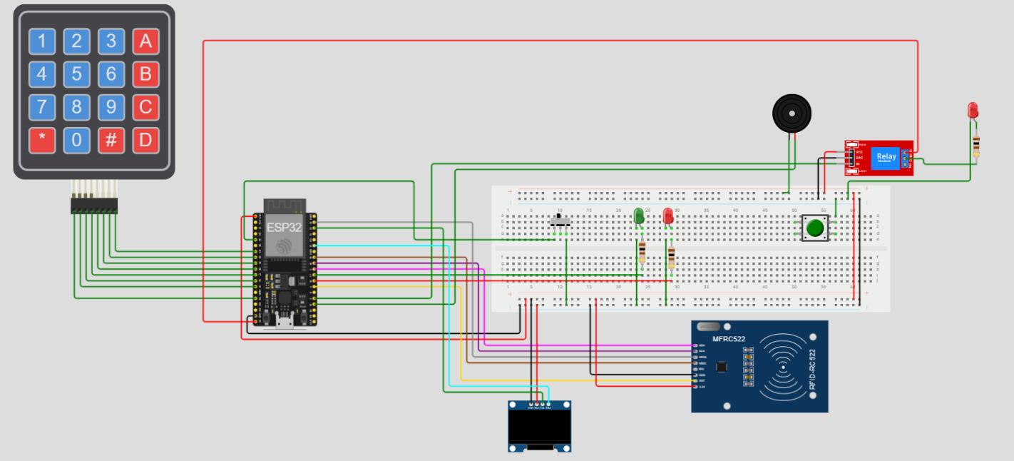
Figure 2. Pre-fabrication simulation of the Smart Safe in Wokwi. The ESP32 sits at the centre of the breadboard; the 4×4 keypad, MFRC522 RFID reader, OLED, relay, status LEDs and buzzer are wired exactly as in the final hardware

5. List of Components
Every part used in the build was selected to balance four criteria: technical sufficiency for the role, availability through local Egyptian electronics suppliers, ease of integration with the ESP32 ecosystem, and unit cost compatible with a practical prototype budget. The detailed cards below summarise the function, key specifications and rationale for each component.

ESP32 Microcontroller (DevKitC v4)
Function | Acts as the system’s central processing unit. Runs the entire firmware, orchestrates the state machine, drives all peripherals, and performs all authentication logic.
Key Specs | Dual-core Xtensa LX6 @ 240 MHz · 520 KB SRAM · 4 MB Flash · Wi-Fi 802.11 b/g/n · Bluetooth 4.2 BR/EDR + BLE · 34 GPIO · 3.3 V logic.
Why Chosen | Selected over the Arduino Uno for its substantially greater processing power, native SPI/I²C/UART, abundant GPIO and built-in wireless radios, which keep the door open for IoT extensions described in §10 without redesigning the board.
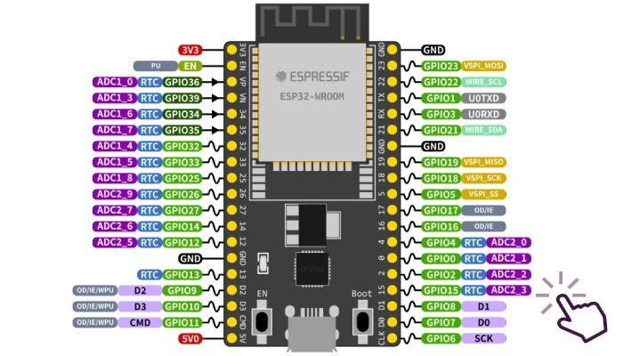

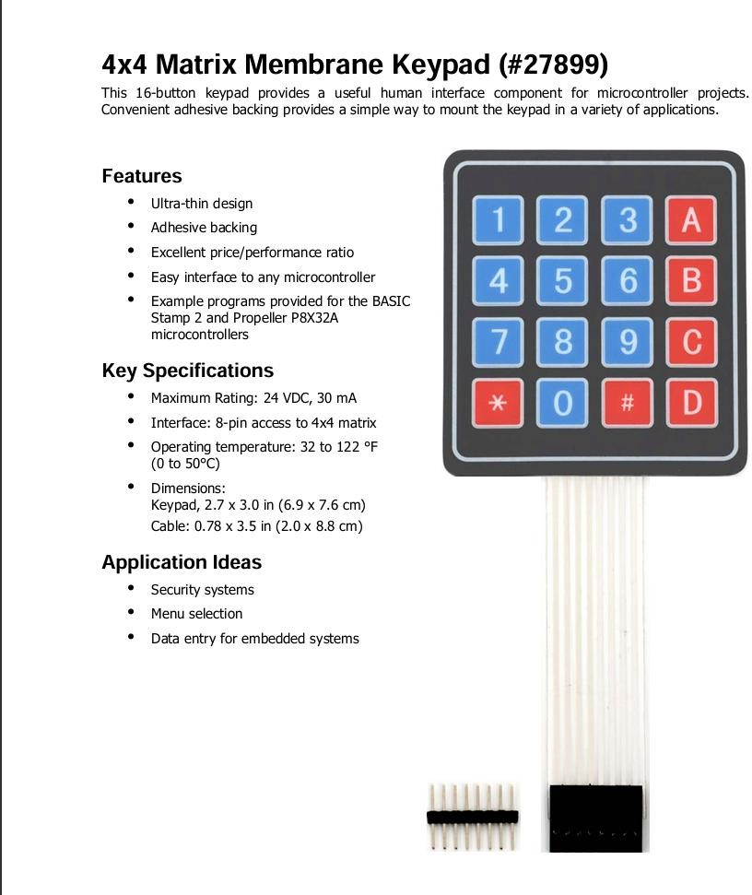
4×4 Membrane Keypad
Function | Provides numeric and command input. Used for PIN entry, the asterisk-backspace and hash-confirm semantics, and the alphabetic A/B keys that select admin operations.
Key Specs | 16 tactile keys (0–9, A–D, *, #) · 8-pin ribbon (4 rows + 4 columns) · adhesive backing · 24 VDC max @ 30 mA · operational from 0 °C to 50 °C.
Why Chosen | The membrane format is thin, dust-resistant and trivially mountable to the front face of the safe. The matrix encoding minimises the number of GPIOs required.

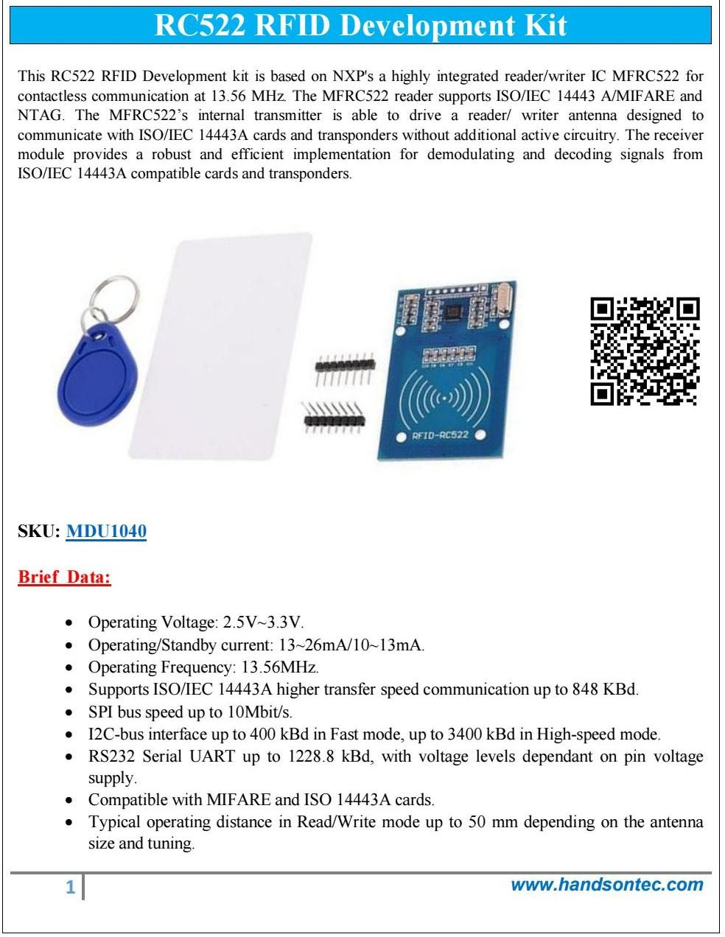
RC522 RFID Reader Module
Function | Reads the UID of MIFARE / ISO-14443A cards held against the front panel and feeds it to the firmware for whitelist matching.
Key Specs | 13.56 MHz · MFRC522 IC · SPI (≤ 10 Mbit/s) / I²C / UART · 2.5–3.3 V · 13–26 mA active · ≤ 50 mm read range · supports MIFARE Classic 1K/4K, Ultralight, NTAG.
Why Chosen | Industry-standard chipset with mature open-source libraries, native 3.3 V compatibility with the ESP32, and adequate read distance for the geometry of the safe door.

RFID Cards / Tags (MIFARE Classic 1K)
Function | Serve as the user-facing credentials. Each authorised individual carries one card; one dedicated master card grants entry to the administrative menu.
Key Specs | ISO/IEC 14443A · 1 KB EEPROM · 13.56 MHz · 32-bit unique UID · credit-card form factor and key-fob form factor included.
Why Chosen | Cheap, durable, easily replaced and rotatable. The ample UID space makes brute-force enumeration computationally infeasible within the lifetime of the safe.

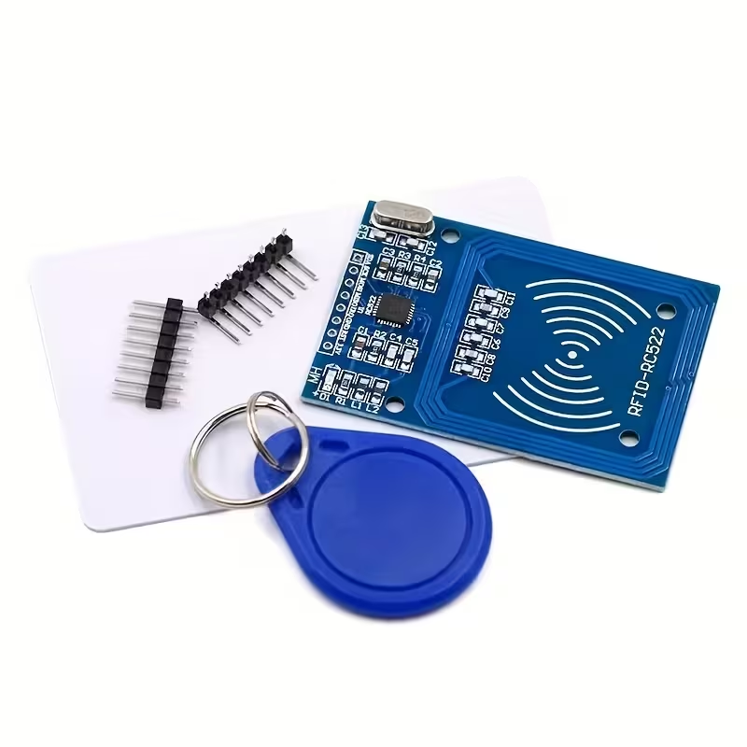

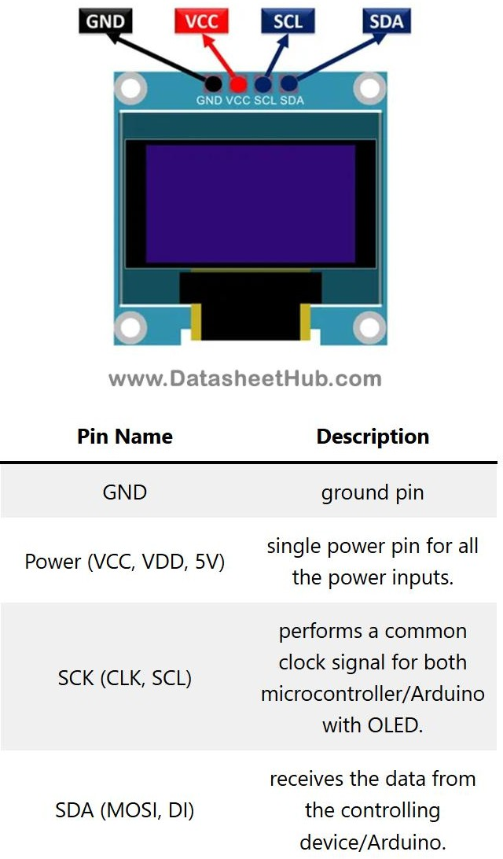
128×64 OLED Display (SH1106, I²C)
Function | Provides the rich visual feedback channel for every system state, including idle animations, scan progress, granted/denied transitions, lock-out countdowns and admin dialogs.
Key Specs | 0.96-inch / 1.3-inch OLED · 128 × 64 pixels · monochrome · I²C (0x3C / 0x3D) · 3.3–5 V · controller IC: SH1106 / SSD1306 compatible.
Why Chosen | OLEDs deliver superior contrast versus LCDs without a backlight, and the U8g2 library exposes a powerful drawing API that enabled the cinematic animation framework described in §3.3.

11 V Spring-Return Solenoid Lock
Function | Performs the mechanical locking action. When energised the plunger retracts and frees the bolt; on de-energisation the spring re-engages, leaving the door fail-secure.
Key Specs | 12 V DC nominal · ~ 800 mA inrush · ~ 200 mA hold · 10 mm stroke · stainless plunger · spring-return.
Why Chosen | Spring-return geometry guarantees fail-secure behaviour during power loss. The 12 V rating matches readily-available battery packs and is comfortably driven by the SRD-05VDC relay.
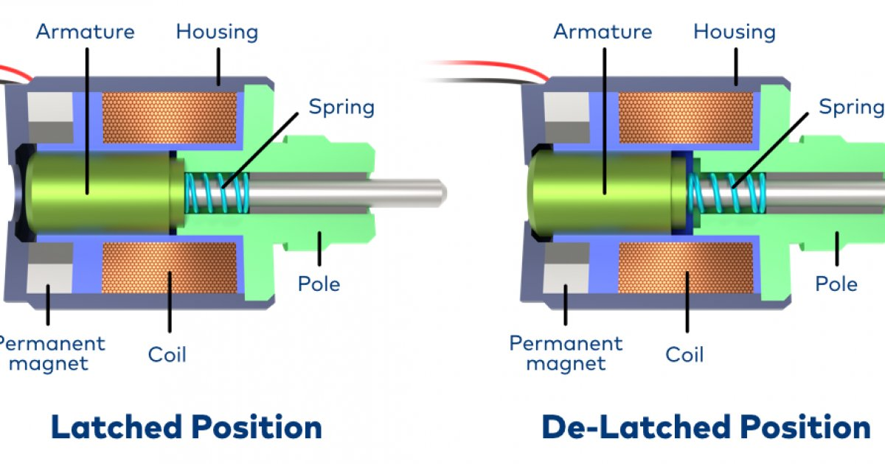
Single-Channel 5 V Relay Module (SRD-05VDC-SL-C)
Function | Acts as the high-side switch isolating the 12 V solenoid path from the 3.3 V ESP32 GPIO. Provides electrical isolation, opto-driven safety and a dedicated flyback diode.
Key Specs | Coil: 5 V · contacts: 10 A @ 250 VAC / 10 A @ 30 VDC · NO/NC/COM screw terminals · on-board status LEDs · low-level trigger.
Why Chosen | Cheap, rugged and explicitly designed to bridge microcontroller signal levels to mains/inductive loads. The on-board LEDs simplified bench debugging.
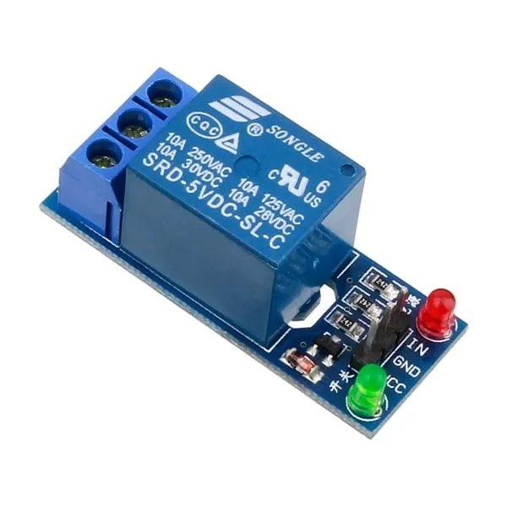
LEDs (Red + Green, 5 mm)
Function | Provide instantaneous status feedback regardless of where the user’s gaze is pointed: green for unlocked, red for denied or lock-out blink.
Key Specs | 5 mm through-hole · forward voltage ≈ 2.0 V (red) / ≈ 2.1 V (green) · 20 mA nominal forward current · viewing angle ≈ 30°.
Why Chosen | Standard, inexpensive, universally familiar, and trivially driven from a 3.3 V GPIO through a 220 Ω current-limiting resistor.

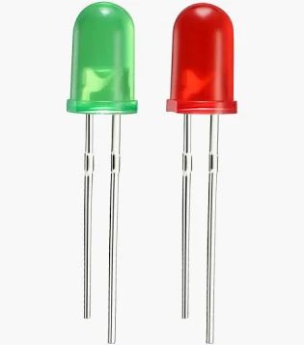
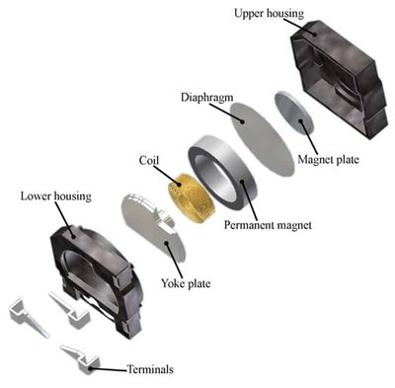
Active Piezo Buzzer
Function | Produces all audible feedback: keypress clicks, success and failure melodies, and the locking confirmation tone.
Key Specs | Operating voltage: 3–5 V · resonant frequency ≈ 2 kHz · sound pressure level ≈ 85 dB @ 10 cm · current ≤ 30 mA.
Why Chosen | The active variant integrates an internal oscillator, allowing the firmware to control it with simple digital tone() calls without requiring a dedicated PWM channel.

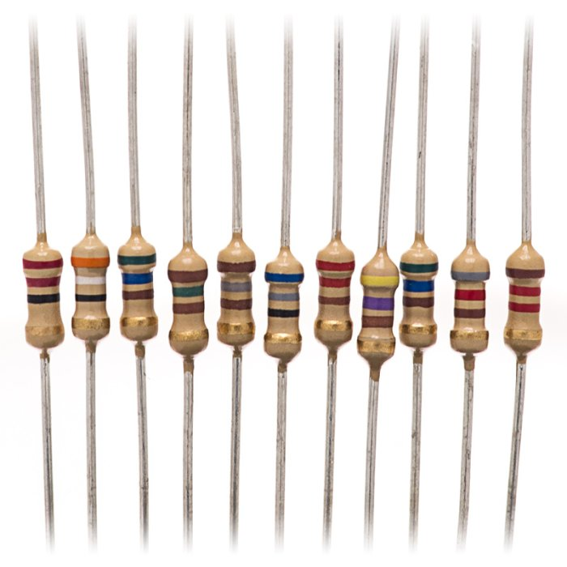
Resistors (¼ W carbon-film)
Function | Limit the forward current through the indicator LEDs and provide pull-down stability for the disarm-switch input pin.
Key Specs | 220 Ω × 2 (LED current limiting) · 10 kΩ × 1 (switch pull-down) · ¼ W · ±5 % tolerance.
Why Chosen | Readily available, inexpensive, and conservative values that yield a comfortable LED brightness while remaining well below the GPIO output current limit.
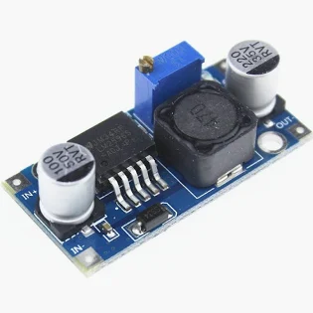
Step-Down Voltage Regulator (LM2596 module)
Function | Converts the variable battery-pack voltage (≈ 14.8 V nominal, 12.0–16.8 V depending on charge) down to the regulated 5 V rail required by the relay, OLED and buzzer.
Key Specs | Adjustable 1.25–35 V output · ≤ 3 A continuous · efficiency ≈ 92 % · on-board trim potentiometer · LM2596S-ADJ controller.
Why Chosen | Switching topology delivers far higher efficiency than a linear regulator, prolonging battery life and limiting heat dissipation inside the safe enclosure.
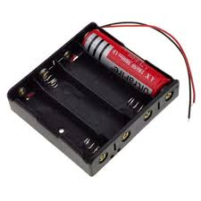
4 × 18650 Lithium-Ion Battery Pack
Function | Provides the primary power source, allowing the safe to operate without mains power and remain functional during outages.
Key Specs | 4 × 18650 cells · 3.7 V nominal each · ≈ 2 600 mAh per cell · series configuration → 14.8 V nominal · plastic 4-cell holder with built-in protection.
Why Chosen | Excellent energy-to-cost ratio, widespread availability, and a nominal voltage that comfortably exceeds the 12 V solenoid rating with headroom for the regulator.
Master ON/OFF Toggle Switch
Function | Disconnects the entire battery pack from the safe’s electronics, used as the primary master cut-off during transport or extended periods of non-use.
Key Specs | SPST · 6 A @ 250 VAC · panel-mount · contact lifetime ≥ 10 000 cycles.
Why Chosen | Simple, robust, and provides a hardware-level guarantee that no current flows through the system when off, eliminating any battery-drain in storage.
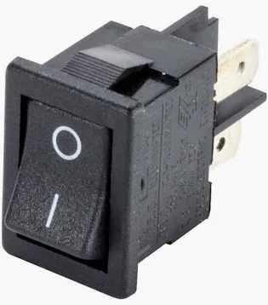

6. Physical Build Circuit & Maquette
This section presents photographic evidence of the final physical build. The first photograph shows the populated breadboard mounted inside the safe enclosure, including the ESP32, the relay, the LM2596 regulator and the 4-cell battery pack. The second documents the closed enclosure with the OLED, RFID antenna, status LEDs, buzzer and keypad mounted on the front face. The third shows the safe in its open configuration, exposing the solenoid bolt and the internal compartment.

6.1 Internal Circuit

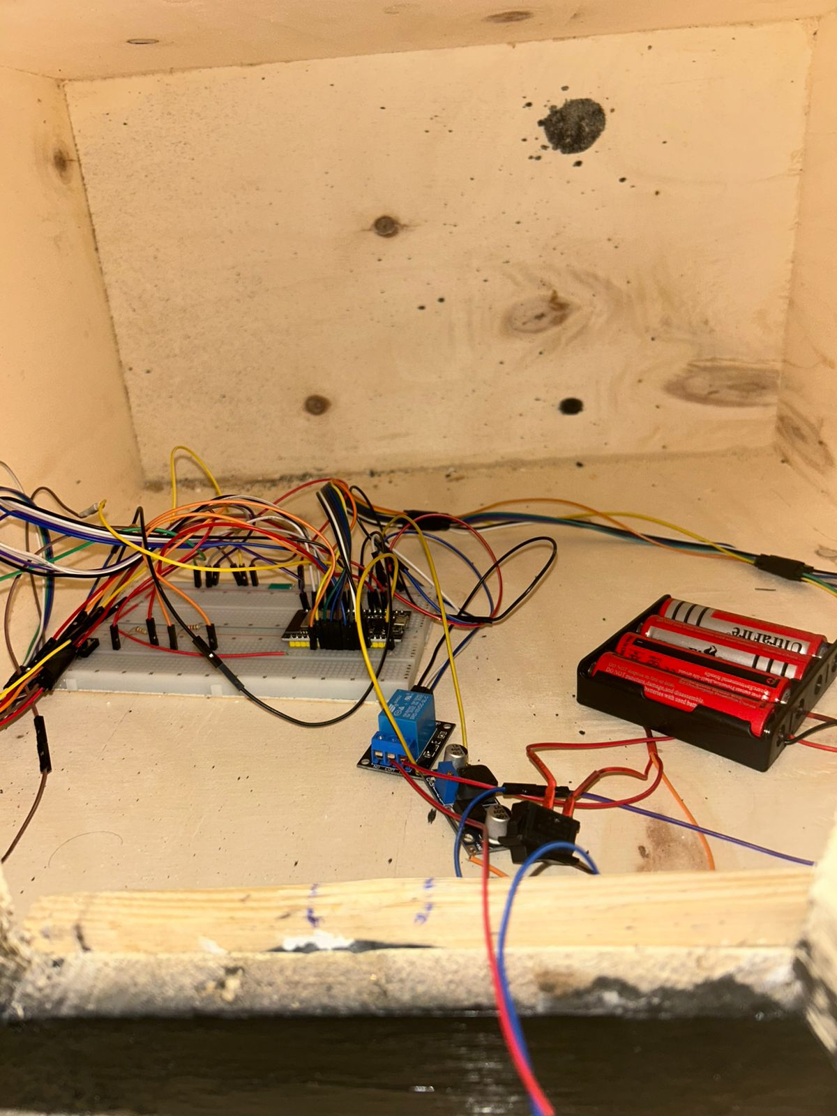
Figure 2. Internal wiring of the safe. The ESP32 is centred on the half-breadboard, with the single-channel relay and LM2596 regulator on the right and the 4-cell 18650 pack at the far right.

6.2 Maquette Closed Configuration
Figure 3. Closed configuration. The OLED, RFID reader, status LEDs, buzzer and 4×4 keypad are flush-mounted on the front panel.

6.3 Maquette Open Configuration
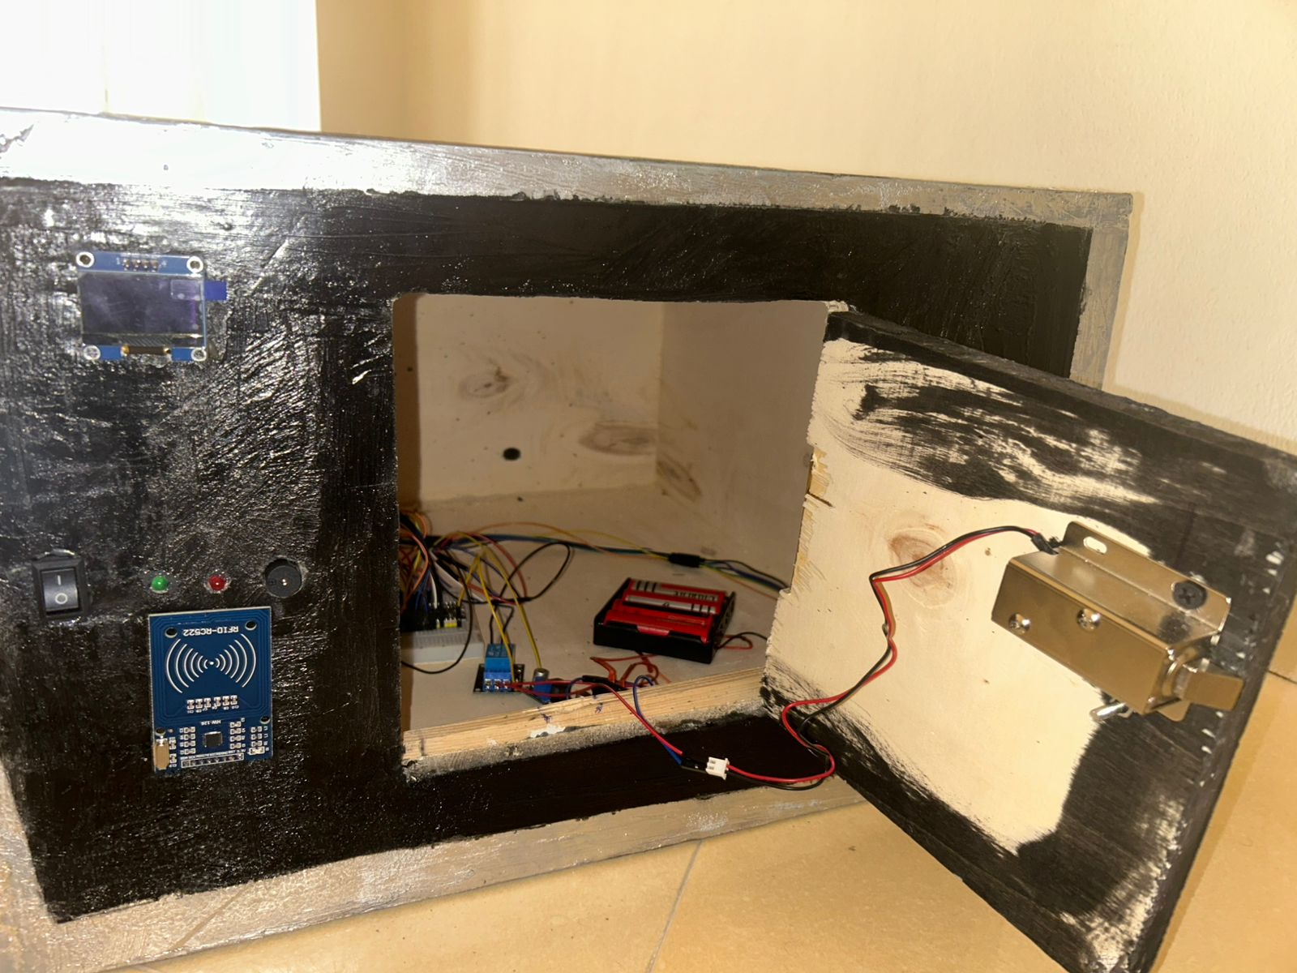
Figure 4. Open configuration. The 12 V solenoid, mounted on the door, retracts to free the bolt; the wiring loom is routed along the inner left edge to keep the storage compartment clear.

7. Implementation Steps

7.1 Mechanical Construction
The enclosure was constructed from 12 mm plywood cut to the dimensions of a small tabletop safe. The inner compartment was finished with primer and matte-black paint to limit reflections that might disturb the OLED contrast, while the outer faces were lightly varnished. A piano-style hinge was inset into the right edge of the door, and the solenoid was screwed to the inside face of the door with its plunger aligned to a metal strike-plate on the body. The front panel was templated and drilled to accept the OLED, RFID antenna, LEDs, buzzer, keypad and master switch.

7.2 Electrical Wiring
Wiring proceeded from power to logic to actuation. The 4-cell 18650 pack was wired through the master toggle switch to the LM2596 regulator, with the regulator then trimmed to deliver a stable 5 V rail. Both the ESP32 (via VIN) and the relay coil were powered from this rail, while the OLED and RC522 took advantage of the ESP32’s on-board 3.3 V regulator. Common ground was rigorously enforced. SPI lines (MOSI/MISO/SCK/SS) were routed in twisted pairs to limit ringing, and the I²C lines to the OLED were kept short and well separated from the SPI bus.

7.3 Pin Map
The final pin assignment is summarised below. It was selected to keep the strapping pins free, to avoid the input-only pins on the GPIO output paths, and to leave the JTAG bus accessible for future debugging.
Peripheral | Signal | ESP32 GPIO
RC522 RFID | SS / RST | 5 / 27
RC522 RFID | SCK / MISO / MOSI | 18 / 19 / 23
OLED | SDA / SCL | 21 / 22 (I²C)
Keypad | Rows 1–4 | 13, 12, 14, 26
Keypad | Cols 1–4 | 25, 33, 32, 3
Relay | Coil drive | 4 (active LOW)
Buzzer | Tone | 15
Green LED | Anode | 2
Red LED | Anode | 16
Disarm SW | Input | 34 (input-only)
Lock Btn | Input | 17

7.4 Firmware Workflow
Development was carried out in the Arduino IDE 2.x with the ESP32 board package installed. The U8g2, MFRC522 and Keypad libraries were added through the library manager. The codebase was authored as a single sketch organised in three layers: a hardware-abstraction layer that wraps each peripheral (readNewCard, refreshRfid, lockDoor, unlockDoor, buzz*), a state-machine dispatcher that maps states to handlers, and a presentation layer of OLED animation routines built on shared helpers (drawCentered, flashScreen, growCircle). Each module was unit-tested in isolation before being integrated into the main loop.

7.5 Testing & Debugging
Once the firmware compiled and flashed cleanly, the team conducted a structured testing campaign that exercised every legal state transition, every authentication outcome, and the brute-force lock-out path. Observations were captured through the serial monitor, the OLED and physical inspection of the relay LED. Two non-trivial defects were uncovered and fixed during this phase: a spurious reset of the RC522 caused by the relay’s inductive kick, and a stuck disarm state caused by contact-bounce on the toggle switch. Both fixes are documented in §9.

8. System Operation
From the operator’s point of view, the safe behaves as a passive standby device that responds deterministically to each interaction. The complete catalogue of supported scenarios is listed below, together with the sequence of internal events triggered by each.
Scenario | System Behaviour
Correct PIN | User presses #, enters the 4-digit reference PIN, presses # again. Firmware transitions IDLE → ENTER_PIN → ACCESS_GRANTED. Relay energises, solenoid retracts, green LED illuminates, success melody plays, OLED shows the UNLOCKED celebration screen, then static UNLOCKED with a hint to press # to re-lock.
Wrong PIN | User enters an incorrect 4-digit PIN and presses #. Firmware transitions ENTER_PIN → ACCESS_DENIED. Red LED illuminates, fail melody plays, OLED shows the ACCESS DENIED animation. Failed-attempt counter increments. After three consecutive failures the system enters the 30-second LOCKOUT state with an animated countdown bar.
Authorised Card | User presents an authorised tag against the RFID reader from IDLE. UID is read, matched against the whitelist and accepted. Firmware transitions to ACCESS_GRANTED with the same actuator and feedback sequence as the PIN path.
Unauthorised Card | User presents an unknown tag. UID is read but does not appear in the whitelist. Firmware transitions to ACCESS_DENIED. The failed-attempt counter increments, contributing to the same lock-out policy as PIN failures.
Master Card / Admin Menu | User presents the master card (or presses *). Firmware transitions to ADMIN_MENU. Pressing A enters ADD_CARD mode (the next scanned UID is enrolled). Pressing B enters REMOVE_CARD mode (the next scanned UID is revoked). Pressing # exits to IDLE. Each operation is confirmed with a card-action animation and a success melody.
Lock the Door | From the ACCESS_GRANTED state, the user presses # or the manual lock button. Firmware transitions to LOCKED. Relay de-energises, solenoid spring re-engages, lock melody plays, OLED shows the DOOR LOCKED animation. After 1.5 s the firmware returns to IDLE.
Disarm the System | User flips the master toggle switch to OFF. After a 40 ms debounce, the firmware enters SYSTEM_DISARMED. All authentication is suspended and the OLED shows a sleeping icon. Flipping the switch back to ON returns the system to IDLE.
Brute-force Lock-out | Three consecutive failed attempts trigger a 30-second LOCKOUT animation with countdown bar and a once-per-second red-LED blink. During this period the keypad and the RFID reader are ignored.

9. Engineering Challenges & Solutions

9.1 RC522 Locking After Relay Switching
During early integration, scanning a card immediately after a lock event would intermittently cause the RC522 to enter an unresponsive state for several seconds. The root cause was traced to the inductive kick from the solenoid coil and to noise injected into the SPI bus during relay actuation. The fix is implemented in the LOCKED state handler, which calls hardResetRfid() exactly once on entry re-initialising the reader and re-enabling its antenna together with a periodic antenna toggle (refreshRfid()) that runs every two seconds in IDLE.

9.2 Toggle-Switch Contact Bounce
The disarm switch initially produced multiple state changes per physical flip, occasionally trapping the firmware in an inconsistent armed/disarmed mix. Hardware filtering was rejected on cost grounds in favour of a software solution: the pollSystemSwitch() helper records the timestamp of every raw transition and only accepts a new value once it has remained stable for 40 ms a debounce window that proved consistently effective without introducing any user-perceivable latency.

9.3 Battery-Powered Voltage Headroom
The 4-cell pack delivers between 12.0 V (depleted) and 16.8 V (fully charged). At full charge the unregulated rail risked exceeding the maximum input rating of the ESP32 board, while at depleted charge it risked falling below the minimum input voltage of the LM2596. The chosen LM2596 covers a 1.25–35 V input range and was trimmed to a stable 5 V output, comfortably accommodating both extremes.

9.4 OLED Contrast Inside the Enclosure
The original mounting plan placed the OLED inside a recessed pocket whose internal walls reflected ambient light, washing out the display. Painting the recess matte black resolved the issue at zero cost and brought the OLED contrast in line with hand-held demonstrations.

9.5 Pin Conflicts with Strapping Pins
Initial pin assignments inadvertently used GPIO 0 and GPIO 12 strapping pins that affect boot mode and flash voltage. The board failed to boot until these signals were re-routed to GPIO 17 and GPIO 13 respectively, after which the boot was reliable across hundreds of power cycles.

10. Future Improvements
The current build delivers all stated objectives and serves as a solid foundation for extensions of greater ambition. The most immediate avenues are catalogued below.

10.1 Mobile-App Integration
The ESP32 already exposes Bluetooth Low Energy and Wi-Fi radios. A companion mobile application could pair with the safe over BLE and expose the administrative menu, the access log and the live system status to the owner, removing the need to physically present the master card.

10.2 Cloud / IoT Telemetry
With the addition of a Wi-Fi credentials provisioning flow, the safe could publish access events to a cloud broker (MQTT, Firebase or AWS IoT Core). A real-time dashboard would let multiple authorised stake-holders observe access events from any location, audit anomalies and receive instant alerts on lock-out conditions.

10.3 Persistent Credential Storage
At present, enrolled cards live in volatile RAM and are lost on power-cycle. Migrating the whitelist into the ESP32 NVS partition (or an external 24LCxx EEPROM) would persist the enrolment across reboots and allow per-user metadata (name, expiry date, time-of-day restrictions) to be associated with each UID.

10.4 Biometric Authentication
A capacitive fingerprint module for example the AS608 could be added as a third authentication channel, satisfying the strongest definition of multi-factor authentication: something you have (the card), something you know (the PIN) and something you are (the fingerprint).

10.5 Tamper Detection & Camera
An on-board MPU-6050 inertial sensor could detect tampering events (knocking, tilting, prying), and an ESP32-CAM module could capture an image of the operator on every failed attempt, forwarding it to the cloud for review.

10.6 Supercapacitor Backup
Inserting a small supercapacitor across the 5 V rail would allow the safe to gracefully complete an in-progress relay actuation in the event of a sudden battery disconnection, preventing the door from being left in an indeterminate state.

11. Conclusion
This project successfully delivered a fully functional, battery-powered Smart Electronic Safe driven by an ESP32 and incorporating dual-channel authentication, animated OLED feedback, audible cues, indicator LEDs, brute-force lock-out, hot-swappable RFID enrolment and a hardware disarm path. Every project objective laid out in §2.4 was met, and the resulting prototype was demonstrated end-to-end without intervention.
From an academic standpoint, the build provided concrete experience with the entire embedded-systems lifecycle: requirement analysis, hardware selection, schematic capture, mechanical fabrication, firmware architecture, peripheral driver integration, finite-state-machine design, debugging under realistic electrical conditions, and finally a structured testing campaign. The team also strengthened its engineering judgement on practical issues that rarely appear in textbooks relay-induced SPI noise, switch debouncing, voltage-headroom planning and ambient-reflection effects on OLED contrast.
Beyond the deliverable itself, the modular architecture of the firmware and the deliberate separation between hardware drivers, the state-machine and the presentation layer leave the project in an excellent position for the future improvements catalogued in §10. Mobile-app integration, cloud telemetry, persistent storage and biometric authentication can all be added incrementally without disturbing the existing logic, exemplifying the value of a well-considered architecture even at the prototype level.

12. Appendix ESP32 Firmware Source Code
The complete firmware listing is reproduced below. The source file is also provided alongside this document as safecode.txt for technical review and future development.
Listing 1. ESP32 RFID Smart-Lock Firmware (main sketch).
​
​
#include <SPI.h>
#include <MFRC522.h>
#include <Wire.h>
#include <U8g2lib.h>
#include <Keypad.h>
#include <BluetoothSerial.h>
​
BluetoothSerial SerialBT;
​
#define BT_DEVICE_NAME "SmartLock_BT"
​
bool greenLedOn = false;
bool redLedOn = false;
​
// ==================== PIN DEFINITIONS ====================
​
#define RFID_SS_PIN 5
#define RFID_RST_PIN 27
#define SCK_PIN 18
#define MISO_PIN 19
#define MOSI_PIN 23
#define RELAY_PIN 4
#define BUZZER_PIN 15
#define GREEN_LED_PIN 2
#define RED_LED_PIN 16
#define SWITCH_PIN 34
#define BUTTON_PIN 17
​
// ==================== HARDWARE OBJECTS ====================
​
U8G2_SH1106_128X64_NONAME_F_HW_I2C u8g2(U8G2_R0, U8X8_PIN_NONE);
MFRC522 rfid(RFID_SS_PIN, RFID_RST_PIN);
​
const byte ROWS = 4, COLS = 4;
char keys[ROWS][COLS] = {
{'1','2','3','A'}, {'4','5','6','B'},
{'7','8','9','C'}, {'*','0','#','D'}
};
byte rowPins[ROWS] = {13, 12, 14, 26};
byte colPins[COLS] = {25, 33, 32, 3};
Keypad keypad = Keypad(makeKeymap(keys), rowPins, colPins, ROWS, COLS);
​
enum SystemState {
STATE_IDLE, STATE_SCAN_RFID, STATE_ENTER_PIN,
STATE_ACCESS_GRANTED, STATE_ACCESS_DENIED, STATE_LOCKED,
STATE_SYSTEM_DISARMED, STATE_ADMIN_MENU,
STATE_ADD_CARD, STATE_REMOVE_CARD, STATE_CHANGE_PIN
};
​
SystemState currentState = STATE_IDLE, previousState = STATE_IDLE;
​
#define MAX_CARDS 10
#define PIN_MAX_LEN 8
#define PIN_MIN_LEN 4
​
byte authorizedCards[MAX_CARDS][4];
int numCards = 0;
byte masterCard[4] = {0x4D, 0xB9, 0x11, 0x7B};
​
​
char correctPIN[PIN_MAX_LEN + 1] = "1234";
char enteredPIN[PIN_MAX_LEN + 1] = {0};
uint8_t pinLen = 0;
​
//the new PIN being typed in the admin menu
char newPIN[PIN_MAX_LEN + 1] = {0};
uint8_t newPinLen = 0;
​
unsigned long stateEntryTime = 0, lastAnimFrame = 0, lastRfidRefresh = 0;
int animFrame = 0, failedAttempts = 0;
bool systemArmed = true, doorLocked = true;
bool lastRawSwitch = true;
unsigned long lastSwitchChange = 0;
​
const uint8_t RELAY_ACTIVE_LEVEL = LOW;
const uint8_t RELAY_INACTIVE_LEVEL = HIGH;
​
#define ACCESS_DISPLAY_TIME 3000
#define LOCKOUT_TIME 30000
#define ANIM_FRAME_DELAY 80
#define RFID_REFRESH_INTERVAL 2000
#define SWITCH_DEBOUNCE_MS 40
#define PIN_TIMEOUT_MS 15000
​
// Fonts
#define FONT_BIG u8g2_font_helvB14_tr
#define FONT_MED u8g2_font_helvB10_tr
#define FONT_SMALL u8g2_font_6x10_tf
#define FONT_TINY u8g2_font_5x7_tf
​
// ==================== FORWARD DECLS ====================
​
void changeState(SystemState newState);
void handleChangePIN();
void animChangePIN();
​
// ==================== SETUP ====================
​
void setup() {
Serial.begin(115200);
Serial.println(F("\n=== RFID Smart Lock Booting ==="));
​
// Pins
pinMode(GREEN_LED_PIN, OUTPUT);
pinMode(RED_LED_PIN, OUTPUT);
pinMode(BUZZER_PIN, OUTPUT);
pinMode(SWITCH_PIN, INPUT);
pinMode(BUTTON_PIN, INPUT);
pinMode(RELAY_PIN, OUTPUT);
digitalWrite(RELAY_PIN, RELAY_INACTIVE_LEVEL);
​
// OLED
Wire.begin(21, 22);
u8g2.begin();
u8g2.clearBuffer();
u8g2.sendBuffer();
​
// RFID
SPI.begin(SCK_PIN, MISO_PIN, MOSI_PIN, RFID_SS_PIN);
rfid.PCD_Init();
delay(50);
rfid.PCD_AntennaOn();
Serial.print(F("RFID Firmware: 0x"));
Serial.println(rfid.PCD_ReadRegister(rfid.VersionReg), HEX);
​
// Bluetooth
SerialBT.begin(BT_DEVICE_NAME);
Serial.println(F("Bluetooth started. Device name: " BT_DEVICE_NAME));
Serial.println(F("BT commands: L=Lock | O=Open | A=Admin"));
​
lockDoor();
animBootSequence();
addCard(masterCard);
changeState(STATE_IDLE);
Serial.println(F("System Ready."));
}
​
// ==================== MAIN LOOP ====================
​
void loop() { tick(); }
​
void tick() {
pollSystemSwitch();
handleBluetooth();
​
if (!systemArmed) {
if (currentState != STATE_SYSTEM_DISARMED) changeState(STATE_SYSTEM_DISARMED);
animSystemDisarmed();
return;
}
if (currentState == STATE_SYSTEM_DISARMED) changeState(STATE_IDLE);
​
//here we handle the the state machine of our program
switch (currentState) {
case STATE_IDLE: handleIdle(); break;
case STATE_SCAN_RFID: handleScanRFID(); break;
case STATE_ENTER_PIN: handleEnterPIN(); break;
case STATE_ACCESS_GRANTED: handleAccessGranted(); break;
case STATE_ACCESS_DENIED: handleAccessDenied(); break;
case STATE_LOCKED: handleLocked(); break;
case STATE_ADMIN_MENU: handleAdminMenu(); break;
case STATE_ADD_CARD: handleAddCard(); break;
case STATE_REMOVE_CARD: handleRemoveCard(); break;
case STATE_CHANGE_PIN: handleChangePIN(); break;
default: changeState(STATE_IDLE); break;
}
}
​
// ===========================================================
// BLUETOOTH
// ===========================================================
/*
* the bluetooth commands:
* L -> LOCK the safe
* O -> OPEN the safe (access granted / unlock)
* A -> open ADMIN MENU
* Anything else -> "Unknown command"
*/
void handleBluetooth() {
if (!SerialBT.available()) return;
​
// Read all available bytes
char btCmd[16] = {0};
int idx = 0;
while (SerialBT.available() && idx < 15) {
char c = (char)SerialBT.read();
if (c == '\n' || c == '\r') continue; // ignore newlines from the app
btCmd[idx++] = c;
}
btCmd[idx] = '\0';
​
if (idx == 0) return;
​
Serial.print(F("BT received: "));
Serial.println(btCmd);
​
// one single character commands
if (idx == 1) {
char c = btCmd[0];
​
// L -> LOCK
if (c == 'L' || c == 'l') {
SerialBT.println("Safe LOCKED.");
Serial.println(F("BT: L -> LOCK"));
changeState(STATE_LOCKED);
return;
}
​
// O -> OPEN / UNLOCK
if (c == 'O' || c == 'o') {
SerialBT.println("Safe UNLOCKED.");
Serial.println(F("BT: O -> OPEN"));
changeState(STATE_ACCESS_GRANTED);
return;
}
​
// A -> ADMIN MENU
if (c == 'A' || c == 'a') {
SerialBT.println("Admin menu opened.");
Serial.println(F("BT: A -> ADMIN MENU"));
changeState(STATE_ADMIN_MENU);
return;
}
}
​
SerialBT.println("Unknown command. Use: L (lock) | O (open) | A (admin)");
}
​
// ==================== the RFID code ====================
​
bool readNewCard() {
return rfid.PICC_IsNewCardPresent() && rfid.PICC_ReadCardSerial();
}
​
void releaseCard() {
rfid.PICC_HaltA();
rfid.PCD_StopCrypto1();
}
​
void refreshRfid() {
if (millis() - lastRfidRefresh < RFID_REFRESH_INTERVAL) return;
lastRfidRefresh = millis();
rfid.PCD_AntennaOff();
delayMicroseconds(100);
rfid.PCD_AntennaOn();
}
​
void hardResetRfid() {
rfid.PCD_Reset();
delay(5);
rfid.PCD_Init();
rfid.PCD_AntennaOn();
lastRfidRefresh = millis();
}
​
// ==================== STATE ====================
​
void handleIdle() {
animIdleScreen();
refreshRfid();
​
if (readNewCard()) {
Serial.print(F("Card scanned: "));
printUID(rfid.uid.uidByte, rfid.uid.size);
​
if (isMasterCard(rfid.uid.uidByte)) changeState(STATE_ADMIN_MENU);
else if (isCardAuthorized(rfid.uid.uidByte)) changeState(STATE_ACCESS_GRANTED);
else changeState(STATE_ACCESS_DENIED);
releaseCard();
return;
}
​
char key = keypad.getKey();
if (key == '#') { clearPIN(); changeState(STATE_ENTER_PIN); }
else if (key == '*') changeState(STATE_ADMIN_MENU);
​
if (digitalRead(BUTTON_PIN) == HIGH && !doorLocked) changeState(STATE_LOCKED);
}
​
void handleScanRFID() {
animScanningRFID();
refreshRfid();
​
if (readNewCard()) {
changeState(isCardAuthorized(rfid.uid.uidByte) ? STATE_ACCESS_GRANTED : STATE_ACCESS_DENIED);
releaseCard();
return;
}
if (keypad.getKey() == '#') changeState(STATE_IDLE);
}
​
void handleEnterPIN() {
animPINEntry();
​
char key = keypad.getKey();
if (key) {
if (key == '#') {
changeState(strcmp(enteredPIN, correctPIN) == 0 ? STATE_ACCESS_GRANTED : STATE_ACCESS_DENIED);
clearPIN();
} else if (key == '*') {
if (pinLen > 0) { enteredPIN[--pinLen] = '\0'; buzzKeypress(); }
} else if (pinLen < PIN_MAX_LEN) {
enteredPIN[pinLen++] = key;
enteredPIN[pinLen] = '\0';
buzzKeypress();
}
}
​
if (millis() - stateEntryTime > PIN_TIMEOUT_MS) { clearPIN(); changeState(STATE_IDLE); }
}
​
void handleAccessGranted() {
if (previousState != STATE_ACCESS_GRANTED) {
animAccessResult(true);
unlockDoor();
buzzSuccess();
setLED(true, false);
failedAttempts = 0;
previousState = STATE_ACCESS_GRANTED;
}
if (keypad.getKey() == '#' || digitalRead(BUTTON_PIN) == HIGH) changeState(STATE_LOCKED);
}
​
void handleAccessDenied() {
if (previousState != STATE_ACCESS_DENIED) {
failedAttempts++;
animAccessResult(false);
buzzFail();
setLED(false, true);
previousState = STATE_ACCESS_DENIED;
}
if (millis() - stateEntryTime > ACCESS_DISPLAY_TIME) {
if (failedAttempts >= 3) { animLockout(); failedAttempts = 0; }
changeState(STATE_IDLE);
}
}
​
void handleLocked() {
if (previousState != STATE_LOCKED) {
lockDoor();
animDoorLocked();
buzzLock();
setLED(false, false);
previousState = STATE_LOCKED;
hardResetRfid();
}
if (millis() - stateEntryTime > 1500) changeState(STATE_IDLE);
}
​
void handleAdminMenu() {
animAdminMenu();
char key = keypad.getKey();
if (key == 'A') changeState(STATE_ADD_CARD);
else if (key == 'B') changeState(STATE_REMOVE_CARD);
else if (key == 'C') { newPinLen = 0; newPIN[0] = '\0'; changeState(STATE_CHANGE_PIN); }
else if (key == '#') changeState(STATE_IDLE);
}
​
void handleAddCard() {
animCardAction(true);
refreshRfid();
​
if (readNewCard()) {
if (!isCardAuthorized(rfid.uid.uidByte)) {
addCard(rfid.uid.uidByte);
animCardResult(true);
buzzSuccess();
} else {
showQuickMessage("Already stored!");
}
releaseCard();
changeState(STATE_ADMIN_MENU);
return;
}
if (keypad.getKey() == '#') changeState(STATE_ADMIN_MENU);
}
​
void handleRemoveCard() {
animCardAction(false);
refreshRfid();
​
if (readNewCard()) {
if (removeCard(rfid.uid.uidByte)) { animCardResult(false); buzzSuccess(); }
else showQuickMessage("Card not found!");
releaseCard();
changeState(STATE_ADMIN_MENU);
return;
}
if (keypad.getKey() == '#') changeState(STATE_ADMIN_MENU);
}
​
// -----------------------------------------------------------
// CHANGE PIN: type new PIN on the keypad, then press # to save
// * = backspace
// # = save (must be at least PIN_MIN_LEN digits)
// D = cancel and return to admin menu
// -----------------------------------------------------------
void handleChangePIN() {
animChangePIN();
​
char key = keypad.getKey();
if (!key) {
// Auto cancel after timeout
if (millis() - stateEntryTime > PIN_TIMEOUT_MS) {
newPinLen = 0;
newPIN[0] = '\0';
showQuickMessage("Cancelled.");
changeState(STATE_ADMIN_MENU);
}
return;
}
​
// Cancel
if (key == 'D') {
newPinLen = 0;
newPIN[0] = '\0';
showQuickMessage("Cancelled.");
changeState(STATE_ADMIN_MENU);
return;
}
​
// Backspace
if (key == '*') {
if (newPinLen > 0) { newPIN[--newPinLen] = '\0'; buzzKeypress(); }
return;
}
​
// Save
if (key == '#') {
if (newPinLen < PIN_MIN_LEN) {
showQuickMessage("PIN too short!");
buzzFail();
return;
}
strncpy(correctPIN, newPIN, PIN_MAX_LEN);
correctPIN[PIN_MAX_LEN] = '\0';
newPinLen = 0;
newPIN[0] = '\0';
​
Serial.print(F("PIN changed to: "));
Serial.println(correctPIN);
SerialBT.print("PIN changed to: ");
SerialBT.println(correctPIN);
​
showQuickMessage("PIN updated!");
buzzSuccess();
changeState(STATE_ADMIN_MENU);
return;
}
​
// Digit (or letter A/B/C — keep digits only for simplicity)
if (key >= '0' && key <= '9' && newPinLen < PIN_MAX_LEN) {
newPIN[newPinLen++] = key;
newPIN[newPinLen] = '\0';
buzzKeypress();
}
}
​
// ==================== UTILITIES ====================
​
void changeState(SystemState newState) {
Serial.print(F("State: ")); Serial.print(currentState);
Serial.print(F(" -> ")); Serial.println(newState);
previousState = currentState;
currentState = newState;
stateEntryTime = millis();
animFrame = 0;
lastAnimFrame = 0;
}
​
void pollSystemSwitch() {
bool raw = (digitalRead(SWITCH_PIN) == HIGH);
if (raw != lastRawSwitch) { lastRawSwitch = raw; lastSwitchChange = millis(); return; }
if (millis() - lastSwitchChange > SWITCH_DEBOUNCE_MS) systemArmed = raw;
}
​
void clearPIN() { pinLen = 0; enteredPIN[0] = '\0'; }
​
bool isCardAuthorized(byte *uid) {
for (int i = 0; i < numCards; i++)
if (memcmp(authorizedCards[i], uid, 4) == 0) return true;
return false;
}
​
bool isMasterCard(byte *uid) { return memcmp(masterCard, uid, 4) == 0; }
​
void addCard(byte *uid) {
if (numCards < MAX_CARDS) {
memcpy(authorizedCards[numCards++], uid, 4);
Serial.print(F("Card added. Total: ")); Serial.println(numCards);
}
}
​
bool removeCard(byte *uid) {
for (int i = 0; i < numCards; i++) {
if (memcmp(authorizedCards[i], uid, 4) == 0) {
for (int j = i; j < numCards - 1; j++)
memcpy(authorizedCards[j], authorizedCards[j + 1], 4);
numCards--;
Serial.print(F("Card removed. Total: ")); Serial.println(numCards);
return true;
}
}
return false;
}
​
void printUID(byte *uid, byte size) {
for (byte i = 0; i < size; i++) {
if (uid[i] < 0x10) Serial.print('0');
Serial.print(uid[i], HEX);
if (i < size - 1) Serial.print(':');
}
Serial.println();
}
​
void unlockDoor() { digitalWrite(RELAY_PIN, RELAY_ACTIVE_LEVEL); doorLocked = false; Serial.println(F("Door UNLOCKED")); }
void lockDoor() { digitalWrite(RELAY_PIN, RELAY_INACTIVE_LEVEL); doorLocked = true; Serial.println(F("Door LOCKED")); }
​
void setLED(bool g, bool r) {
digitalWrite(GREEN_LED_PIN, g ? HIGH : LOW);
digitalWrite(RED_LED_PIN, r ? HIGH : LOW);
}
​
// ==================== BUZZER ====================
​
void playMelody(const int *freqs, const int *durs, int count) {
for (int i = 0; i < count; i++) {
tone(BUZZER_PIN, freqs[i], durs[i]);
if (i < count - 1) delay(durs[i] + 20);
}
}
​
void buzzKeypress() { tone(BUZZER_PIN, 1200, 50); }
void buzzSuccess() { int f[] = {1000, 1500, 2000}; int d[] = {120, 120, 150}; playMelody(f, d, 3); }
void buzzFail() { int f[] = {400, 300}; int d[] = {250, 400}; playMelody(f, d, 2); }
void buzzLock() { int f[] = {800, 600}; int d[] = {80, 150}; playMelody(f, d, 2); }
​
// ===========================================================
// OLED display
// ===========================================================
​
void drawCentered(const char* s, int y, const uint8_t* font) {
u8g2.setFont(font);
u8g2.drawStr((128 - u8g2.getStrWidth(s)) / 2, y, s);
}
​
void flashScreen(int times, int onMs, int offMs) {
for (int i = 0; i < times; i++) {
u8g2.clearBuffer(); u8g2.drawBox(0, 0, 128, 64); u8g2.sendBuffer();
delay(onMs);
u8g2.clearBuffer(); u8g2.sendBuffer();
delay(offMs);
}
}
​
void growCircle(int cx, int cy, int maxR, int step, int d) {
for (int r = 0; r <= maxR; r += step) {
u8g2.clearBuffer();
u8g2.drawCircle(cx, cy, r);
u8g2.sendBuffer();
delay(d);
}
}
​
void drawLockIcon(int lx, int ly) {
u8g2.drawRFrame(lx + 5, ly, 14, 16, 7);
u8g2.drawRFrame(lx + 6, ly + 1, 12, 14, 6);
u8g2.drawRBox(lx, ly + 12, 24, 18, 3);
u8g2.setDrawColor(0);
u8g2.drawDisc(lx + 12, ly + 19, 3);
u8g2.drawBox(lx + 11, ly + 21, 3, 5);
u8g2.setDrawColor(1);
}
​
void showQuickMessage(const char *msg) {
u8g2.clearBuffer();
drawCentered(msg, 34, FONT_SMALL);
u8g2.sendBuffer();
delay(1000);
}
​
// ===========================================================
// ANIMATIONS
// ===========================================================
​
void animBootSequence() {
for (int i = 0; i < 128; i += 6) {
u8g2.clearBuffer();
u8g2.drawLine(i, 0, 128 - i, 64);
u8g2.sendBuffer();
}
growCircle(64, 32, 40, 4, 8);
flashScreen(1, 60, 80);
​
const char* title = "SMART LOCK";
const char* sub = "v1.1 + BT";
for (int i = 0; i <= (int)strlen(title); i++) {
u8g2.clearBuffer();
char partial[12] = {0};
strncpy(partial, title, i);
drawCentered(partial, 30, FONT_BIG);
if (i == (int)strlen(title)) drawCentered(sub, 48, FONT_SMALL);
u8g2.sendBuffer();
delay(40);
}
delay(300);
​
u8g2.clearBuffer();
u8g2.setFont(FONT_SMALL);
u8g2.drawStr(34, 26, "LOADING...");
u8g2.drawFrame(14, 36, 100, 14);
u8g2.sendBuffer();
for (int i = 0; i < 96; i += 8) {
u8g2.drawBox(16, 38, i, 10);
u8g2.sendBuffer();
delay(15);
}
delay(150);
​
for (int i = 0; i < 2; i++) {
u8g2.clearBuffer(); u8g2.sendBuffer();
delay(60);
u8g2.clearBuffer();
drawCentered("READY", 38, FONT_BIG);
u8g2.sendBuffer();
delay(120);
}
delay(200);
}
​
void animIdleScreen() {
if (millis() - lastAnimFrame < 800) return;
lastAnimFrame = millis();
animFrame = (animFrame + 1) % 4;
​
u8g2.clearBuffer();
drawLockIcon(52, 2);
​
for (int i = 0; i < 3; i++) {
int dx = 50 + (i * 12);
if (i <= (animFrame % 3)) u8g2.drawDisc(dx, 40, 2);
else u8g2.drawCircle(dx, 40, 2);
}
​
u8g2.setFont(FONT_TINY);
u8g2.drawStr(0, 7, doorLocked ? "[LOCKED]" : "[OPEN]");
u8g2.drawStr(6, 56, "Scan card or press #");
u8g2.sendBuffer();
}
​
void animScanningRFID() {
if (millis() - lastAnimFrame < ANIM_FRAME_DELAY) return;
lastAnimFrame = millis();
animFrame++;
​
u8g2.clearBuffer();
for (int i = 0; i < 4; i++) {
int r = ((animFrame * 3) + (i * 10)) % 40;
if (r > 5) u8g2.drawCircle(64, 28, r);
}
​
u8g2.setDrawColor(0); u8g2.drawBox(54, 20, 20, 16); u8g2.setDrawColor(1);
u8g2.drawRFrame(54, 20, 20, 16, 2);
u8g2.drawHLine(58, 26, 10);
u8g2.drawHLine(58, 30, 6);
​
u8g2.setFont(FONT_TINY);
u8g2.drawStr(14, 60, "Scanning... [#]=Back");
u8g2.sendBuffer();
}
​
void animPINEntry() {
u8g2.clearBuffer();
drawCentered("ENTER PIN", 12, FONT_MED);
u8g2.drawHLine(0, 15, 128);
​
int startX = 64 - (pinLen * 14) / 2;
for (int i = 0; i < pinLen; i++)
u8g2.drawDisc(startX + (i * 14) + 5, 32, 5);
​
if ((millis() / 500) % 2 == 0 && pinLen < PIN_MAX_LEN)
u8g2.drawVLine(startX + (pinLen * 14) + 3, 26, 12);
​
u8g2.setFont(FONT_TINY);
u8g2.drawStr(0, 54, "[#]OK [*]Del");
​
char buf[8];
snprintf(buf, sizeof(buf), "%d/8", pinLen);
u8g2.drawStr(128 - u8g2.getStrWidth(buf) - 2, 54, buf);
u8g2.sendBuffer();
}
​
// screen for typing a NEW PIN
void animChangePIN() {
u8g2.clearBuffer();
drawCentered("NEW PIN", 12, FONT_MED);
u8g2.drawHLine(0, 15, 128);
​
// Show typed digits in clear text
u8g2.setFont(FONT_BIG);
int w = u8g2.getStrWidth(newPIN);
u8g2.drawStr((128 - w) / 2, 38, newPIN);
​
// Blinking caret
if ((millis() / 500) % 2 == 0 && newPinLen < PIN_MAX_LEN) {
int cx = (128 - w) / 2 + w + 1;
u8g2.drawVLine(cx, 26, 14);
}
​
u8g2.setFont(FONT_TINY);
u8g2.drawStr(0, 54, "[#]Save [*]Del [D]Cancel");
​
char buf[12];
snprintf(buf, sizeof(buf), "%d/%d", newPinLen, PIN_MAX_LEN);
u8g2.drawStr(128 - u8g2.getStrWidth(buf) - 2, 62, buf);
​
u8g2.sendBuffer();
}
​
void animAccessResult(bool granted) {
flashScreen(2, 30, 30);
​
if (!granted) {
for (int i = 0; i < 4; i++) {
u8g2.clearBuffer();
int ox = (i % 2 == 0) ? 3 : -3;
u8g2.setFont(FONT_BIG);
u8g2.drawStr(58 + ox, 26, "X");
u8g2.sendBuffer();
delay(40);
}
}
​
growCircle(64, 26, 22, 4, 8);
​
if (granted) {
for (int i = 0; i <= 8; i += 2) { u8g2.drawLine(52, 26, 52 + i, 26 + i); u8g2.sendBuffer(); delay(12); }
for (int i = 0; i <= 16; i += 2) { u8g2.drawLine(60, 34, 60 + i, 34 - i); u8g2.sendBuffer(); delay(10); }
} else {
for (int i = 0; i <= 20; i += 2) {
u8g2.drawLine(50, 14, 50 + i, 14 + i);
u8g2.drawLine(78, 14, 78 - i, 14 + i);
u8g2.sendBuffer();
delay(10);
}
}
​
u8g2.drawDisc(64, 26, 22);
u8g2.setDrawColor(0);
if (granted) {
for (int t = -1; t <= 1; t++) {
u8g2.drawLine(52, 26 + t, 60, 34 + t);
u8g2.drawLine(60, 34 + t, 76, 18 + t);
}
} else {
for (int t = -1; t <= 1; t++) {
u8g2.drawLine(52, 16 + t, 76, 36 + t);
u8g2.drawLine(76, 16 + t, 52, 36 + t);
}
}
u8g2.setDrawColor(1);
​
drawCentered(granted ? "ACCESS GRANTED" : "ACCESS DENIED", 60, FONT_SMALL);
u8g2.sendBuffer();
delay(granted ? 500 : 800);
​
if (!granted) return;
​
for (int x = 0; x <= 128; x += 16) {
u8g2.clearBuffer();
u8g2.drawBox(0, 0, x, 64);
u8g2.setDrawColor(0);
drawCentered("UNLOCKED", 38, FONT_BIG);
u8g2.setDrawColor(1);
u8g2.sendBuffer();
delay(10);
}
delay(200);
​
u8g2.clearBuffer();
drawCentered("UNLOCKED", 28, FONT_BIG);
u8g2.setFont(FONT_TINY);
u8g2.drawStr(12, 50, "Press # to lock");
u8g2.sendBuffer();
}
​
void animDoorLocked() {
for (int y = -8; y <= 0; y += 4) {
u8g2.clearBuffer();
int lx = 52, ly = 10;
u8g2.drawRBox(lx, ly + 14, 24, 18, 3);
u8g2.drawRFrame(lx + 5, ly + y, 14, 16, 7);
u8g2.drawRFrame(lx + 6, ly + y + 1, 12, 14, 6);
u8g2.setDrawColor(0);
u8g2.drawDisc(lx + 12, ly + 21, 3);
u8g2.drawBox(lx + 11, ly + 23, 3, 4);
u8g2.setDrawColor(1);
u8g2.sendBuffer();
delay(25);
}
drawCentered("DOOR LOCKED", 56, FONT_MED);
u8g2.sendBuffer();
delay(500);
}
​
void animSystemDisarmed() {
if (millis() - lastAnimFrame < 500) return;
lastAnimFrame = millis();
​
u8g2.clearBuffer();
u8g2.drawDisc(64, 24, 16);
u8g2.setDrawColor(0); u8g2.drawDisc(72, 18, 14); u8g2.setDrawColor(1);
​
u8g2.setFont(FONT_MED); u8g2.drawStr(80, 16, "Z");
u8g2.setFont(FONT_SMALL); u8g2.drawStr(90, 10, "z");
u8g2.setFont(FONT_TINY); u8g2.drawStr(96, 6, "z");
​
drawCentered("SYSTEM DISARMED", 56, FONT_SMALL);
u8g2.sendBuffer();
}
​
void animLockout() {
u8g2.clearBuffer();
u8g2.setFont(FONT_SMALL);
u8g2.drawStr(8, 16, "TOO MANY ATTEMPTS");
u8g2.sendBuffer();
​
int seconds = LOCKOUT_TIME / 1000;
for (int s = seconds; s >= 0; s--) {
u8g2.setDrawColor(0); u8g2.drawBox(0, 24, 128, 40); u8g2.setDrawColor(1);
​
char buf[8];
snprintf(buf, sizeof(buf), "%ds", s);
drawCentered(buf, 44, FONT_BIG);
​
int barW = map(s, seconds, 0, 96, 0);
u8g2.drawFrame(14, 50, 100, 10);
u8g2.drawBox(16, 52, barW, 6);
​
u8g2.sendBuffer();
delay(1000);
digitalWrite(RED_LED_PIN, (s % 2 == 0) ? HIGH : LOW);
}
digitalWrite(RED_LED_PIN, LOW);
}
​
void animAdminMenu() {
if (millis() - lastAnimFrame < 300) return;
lastAnimFrame = millis();
​
u8g2.clearBuffer();
drawCentered("ADMIN MENU", 11, FONT_MED);
u8g2.drawHLine(0, 14, 128);
​
u8g2.setFont(FONT_TINY);
u8g2.drawStr(6, 24, "[A] Add new card");
u8g2.drawStr(6, 34, "[B] Remove card");
u8g2.drawStr(6, 44, "[C] Change PIN");
u8g2.drawStr(6, 54, "[#] Exit");
​
char buf[16];
snprintf(buf, sizeof(buf), "Cards:%d/%d", numCards, MAX_CARDS);
u8g2.drawStr(128 - u8g2.getStrWidth(buf) - 2, 62, buf);
u8g2.sendBuffer();
}
​
void animCardAction(bool adding) {
if (millis() - lastAnimFrame < ANIM_FRAME_DELAY * 2) return;
lastAnimFrame = millis();
animFrame++;
​
u8g2.clearBuffer();
drawCentered(adding ? "ADD CARD" : "REMOVE CARD", 12, FONT_MED);
u8g2.drawHLine(0, 15, 128);
​
if (adding) {
int arrowY = 22 + ((animFrame % 8) < 4 ? (animFrame % 4) * 2 : (4 - (animFrame % 4)) * 2);
u8g2.drawLine(64, arrowY, 58, arrowY - 6);
u8g2.drawLine(64, arrowY, 70, arrowY - 6);
u8g2.drawRFrame(50, 34, 28, 18, 3);
u8g2.drawHLine(54, 40, 12);
u8g2.drawHLine(54, 44, 8);
u8g2.setFont(FONT_TINY);
u8g2.drawStr(4, 62, "Place card... [#]Back");
} else {
u8g2.drawRFrame(50, 24, 28, 18, 3);
if ((animFrame / 4) % 2 == 0) {
u8g2.drawLine(54, 28, 72, 38);
u8g2.drawLine(72, 28, 54, 38);
}
u8g2.setFont(FONT_TINY);
u8g2.drawStr(2, 62, "Scan to remove [#]Back");
}
u8g2.sendBuffer();
}
​
void animCardResult(bool added) {
u8g2.clearBuffer();
drawCentered(added ? "CARD ADDED!" : "CARD REMOVED!", 20, FONT_MED);
​
if (added) {
for (int s = 0; s <= 10; s += 4) {
u8g2.drawBox(60, 34 - s, 8, s * 2);
u8g2.drawBox(60 - s, 34 - 4, s * 2, 8);
u8g2.sendBuffer();
delay(20);
}
} else {
for (int s = 14; s >= 0; s -= 4) {
u8g2.setDrawColor(0); u8g2.drawBox(46, 26, 36, 24); u8g2.setDrawColor(1);
if (s > 0) u8g2.drawRFrame(64 - s, 38 - (s * 9 / 7), s * 2, (s * 18 / 14), 2);
u8g2.sendBuffer();
delay(25);
}
}
​
char buf[16];
snprintf(buf, sizeof(buf), added ? "Total: %d" : "Remaining: %d", numCards);
drawCentered(buf, 58, FONT_SMALL);
u8g2.sendBuffer();
delay(800);
}

